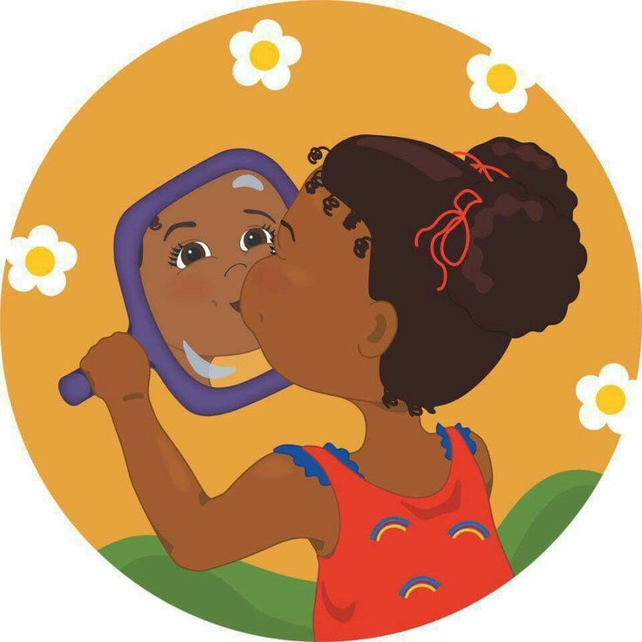**Exploring Emotions**

During bathroom routines, have your child look in the mirror and practice making mad/sad/happy faces together. You can make a happy face and say (for example), “I have a happy face because I’m happy to be here with you!” Ask your child, “What makes you have a happy face?” You can do the same with other emotions such as angry/mad face, sad face, silly face, …

Here is a video with the Storybots about emotions. It has lots of fun music to dance to. It is 11 minutes long: <https://youtu.be/akTRWJZMks0>